For IP&S use only

PLEASE DO NOT DISCLOSE YOUR INVENTION BEFORE A PATENT APPLICATION IS FILED
Docket No. (to be filled in by IP Business)
Originating IP&S SiteVersion No. (to be filled in by IP Business)

*** For urgent matters, please contact your patent attorney ***

PART I – INFORMATION SHEET (Mandatory – Complete All Fields) DATE:

TITLE (10 words maximum)
Method and apparatus for buffer overflow protection

Development Project Reference: <personal project>

Originating BD/BU/Product Line (please select from drop downs):
Research / CTO | Carrier | Enterprise | Services

Main INVENTOR
Last Name (surname)  van Bemmel |  |  | First Name  Jeroen |  |  |  | Middle Initial | HRID or UPI  0912867 |  |  |  | Alcatel-Lucent Employee?
 |  |  |  |  |  |  |  |  |  |  |  | Yes |  | No
Employer Alcatel-Lucent Netherlands BV |  |  |  |  |  |  | If No, provide contact:
Business Unit  Sales |  | Position  Business Developer |  |  |  | Supervisor Name  Gerwin Franken |  |  |  |  | Supervisor Phone No.  +31 653163498
Phone  +31 6 12150492 | E-mail Address  jbemmel@alcatel-lucent.com |  |  |  | Citizenship  Dutch |  |  |  |  | Country  Netherlands
Home Address  Oude Singel 88 |  |  |  | City  Leiden |  |  |  |  | State |  |  |  | Zip Code  2312RD

Other INVENTORS
Last Name (surname) |  |  | First Name |  |  |  | Middle Initial | HRID or UPI |  |  |  | Alcatel-Lucent Employee?
 |  |  |  |  |  |  |  |  |  |  |  | Yes |  | No
Employer |  |  |  |  |  |  | If No, provide contact:
Business Unit |  | Position |  |  |  | Supervisor Name |  |  |  |  | Supervisor Phone No.
Phone | E-mail Address |  |  |  | Citizenship |  |  |  |  | Country
Home Address |  |  |  | City |  |  |  |  | State |  |  |  | Zip Code

Last Name (surname) |  |  | First Name |  |  |  | Middle Initial | HRID or UPI |  |  |  | Alcatel-Lucent Employee?
 |  |  |  |  |  |  |  |  |  |  |  | Yes |  | No
Employer |  |  |  |  |  |  | If No, provide contact:
Business Unit |  | Position |  |  |  | Supervisor Name |  |  |  |  | Supervisor Phone No.
Phone | E-mail Address |  |  |  | Citizenship |  |  |  |  | Country
Home Address |  |  |  | City |  |  |  |  | State |  |  |  | Zip Code

⇨ For additional inventor(s), please go to the end of this document.

SOURCE of FUNDING
EXTERNAL FUNDING (if any):
List of external organizations (EC, MEFI, government, etc.), contact information and contract date
Organization | Name | Phone | E-mail | Contract Date
(If applicable)
Government contract number: Government Contract Manager Name:

COLLABORATION (if any):
List of laboratories / companies, contact information and contract date
Laboratory / Company | Name | Phone | E-mail | Contract Date

Business Division(s) with potential interest (Include contact name, if available):
BD |  | Contact
BD |  | Contact

IMPORTANT: if the invention is expected to be publicly disclosed (by way of a publication, technical presentation or otherwise), to be sold or otherwise made available to third parties in the form of products or equipment incorporating it or to be communicated to others for any reason, please indicate here the expected date and circumstances:
Yes (please, answer below) No (go to Part II)
Standardization organization (for actual or potential proposal to Standardization Organization)
Organization | Group | Sub-group | Alcatel-Lucent Contact | Deadline / Date

Publication | Deadline / Date

Name of Publication:

Submitted to Publication Clearance? | Yes | No

Other potential public disclosures or offers for sale (sales, exhibition, show, supplier contact, etc.) | Deadline / Date

PART II - TECHNICAL DESCRIPTION (Note: Fields will expand)

PLEASE AVOID THE USE OF UNDEFINED ACRONYMS AND JARGON

What is the technical problem that the inventor(s) had to solve?
Many attacks to execute arbitrary code are based on exploiting buffer overflows, i.e. programming errors in existing code which fail to check buffer limits when writing to the buffer. The technical problem is to design an operating system in such a way that exploiting buffer overflows is very hard.

What is the best existing solution of this problem, to the knowledge of the inventor(s) AND why this solution is not good enough?
Many approaches exist to guard against buffer overflows:
- hardware based (taking advantage of either segment limit protection or per-page “non-execute” bits in recent CPUs)
- compiler based (e.g. generating so-called ‘canary’ values on the stack, to detect stack buffer overflows)
- OS based (e.g. Windows supports “Address Space Layout Randomization(ASLR)”,
- third party module based (e.g. using a kernel driver to modify address layout)
Windows has several built-in protection mechanisms to guard against buffer overflows. However, a recent article on Black Hat (http://searchsecurity.techtarget.com/news/article/0,289142,sid14_gci1324395,00.html) demonstrates that even the latest Windows Vista “enhancements” are easily bypassed.
Compiler-based approaches require recompilation of all existing code, which is usually not feasible.
A paper in 2005 entitled “Buffer Overflow Protection Based on Adjusting
Code Segment Limit” (see http://ieeexplore.ieee.org/iel5/10481/33237/01567023.pdf?tp=&isnumber=&arnumber=1567023) describes a method that works by relocating the usermode stack to an address outside the executable segment space. However, this approach only protects against code executing from the stack (while an attacker can easily allocate attack code on the dynamic heap). It also only defends against usermode attacks, and not kernel mode.
Newer CPUs like the AMD Athlon 64 and the Intel Pentium 4 provide page-level “execute protect” bits. Obvious drawbacks of this approach is that it does not work on earlier processors, and the implementation is complex and error-prone: it requires the use of 64-bit page table entries, and the bit must be set on every page containing stack or data memory consistently.
Description of existing OpenBSD mechanisms: http://kerneltrap.org/node/573. At the time the i386 did not yet offer per-page execute protection, it was not realized that the segment limit mechanisms can be used to protect both stack and data buffers.
Existing patents:
- see http://www.patentstorm.us/patents/7231666.html (IBM), which describes a method based on limiting the length of strings passed as parameters (in particular when containing environment variables)
- see http://www.patentstorm.us/patents/6412071.html (Entercept), which describes a method based on limiting invocation of potentially vulnerable procedures to a restricted set of caller addresses (“approved” call points). This method introduces processing overhead (address check against a list for each invocation) and requires that a list of valid calling points is associated with every executable.
- see http://www.patentstorm.us/patents/7086088.html, which is based on encrypting the return address placed on the stack (buffer overflow is detected when decryption fails). In an OS-based embodiment, “call” instructions would be replaced with special opcodes (e.g. ‘int’) to trigger encryption. This introduces processing overhead for each procedure call, and would not work for self-modifying code or code that is placed in the data section of the executable

(Drawings illustrating this existing solution are welcome – please attach separately)

Basic idea of the inventor’s solution
The basic idea of this invention is to design the operating system in such a way that code execution from both stack and data memory is prevented.

Description of at least one embodiment of the solution accompanied by appropriate drawings
One embodiment of this invention leverages the segment protection features available on Intel X86 processors. The operating system’s usage of the available virtual address space (typically 4Gb on 32-bit CPUs) is organized as per figure 1.
Like most contemporal OS, this embodiment uses a so-called “flat memory model” in which all memory is addressable in a linear fashion. However, unlike prior art, this embodiment uses segmentation (possibly in addition to other methods such as paging) for protection. All segments are zero-based, but the upper limit of each segment varies by design, depending on the executing privilege and nature of the segment (code(CS) or data(DS)/ stack(SS, set equal to DS))
The operating system (like most OS) provides at least 2 different privilege levels for execution, “supervisor” level (DPL=0) and “user” level (DPL=3). Code executing at “user” level uses a different set of segment descriptors (shown on the left) than code executing at “supervisor” level (shown on the right). Consequently, “user level” code cannot address (i.e. read/write or execute) memory that belongs to the kernel.

Code executing at “user” level uses user stacks and user data. Because both these areas are beyond the user code segment, a buffer overflow attack which overwrites the return address to point to attacker-supplied code either on the stack (i.e. by providing the code as part of the string that overwrites the buffer content) or in the data memory (i.e. using dynamic memory allocation) will fail (trigger a segment protection exception).

Likewise, code executing at “supervisor” level cannot be redirected to attack code residing in either the kernel stack or kernel data memory.

Note that this invention does not protect against so-called “return-to-libc” attacks, which overwrite the return address to a valid address in the existing code segment (at the same privilege level). This invention also implies that software designed to execute legitimate code on the stack or in data memory (such as e.g. the GCC compiler, which uses so-called “trampolines” in certain cases) needs to be redesigned. To support this, the OS in this embodiment would provide an API call that allows software to allocate memory for executing such code, without triggering buffer overflow protection. For security reasons, the use of this API would be restricted (e.g. to a list of well-known components). Alternatively, the software would be redesigned to avoid executing code in non-code memory.
Also note that the order of the sections shown in figure 1 could vary. For example, the “kernel stacks” section could be placed between the “kernel code” and the “kernel data” sections, without affecting the application of this invention. The essential guidelines are:
- code sections must be separated from data/stack sections
- data/stack sections must be placed at higher addresses than code sections
- “user level” code/stack/data sections must be separated from “supervisor level” sections
- “supervisor level” sections (green/orange) must be placed at higher addresses than “user level” sections (blue)

Please attach drawings below
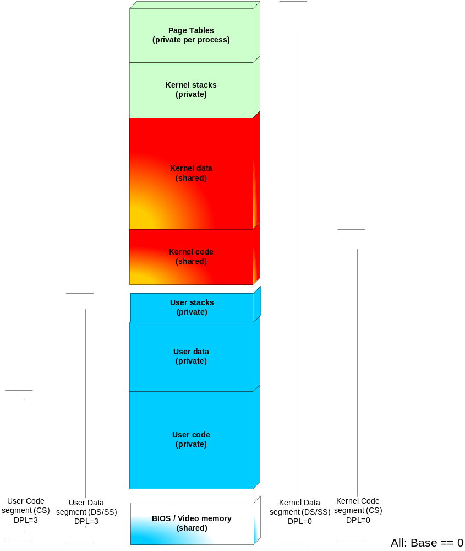

Figure 1 – Addess space layout using segmentation limits to
prevent code execution in stack or data pages

PART III – (PATENT) COMMERCIAL VALUE (Note: Fields will expand)
(to be completed by THE INVENTOR(S) OR the local IP counsel with the help of experts IF not available from the inventor(s))

What is the value and/or the unique benefits of the invention?
This invention offers a non-obtrusive design approach for operating systems which protects against buffer overflow attacks.

What are the advantages of the new solution over the best existing solution (if possible, quantify)?
This invention requires no recompilation of external software (i.e. software not part of the OS), and imposes only limited design restrictions on such software. It does not introduce any runtime overhead for protection, and is simple to implement on generally available CPUs (including older versions). It protects against execution of attacker-code residing either in stack memory (as some prior art does) or in dynamically allocated data memory (new, to counter heap smashing attacks).

What is the likelihood of use by others?
Likely, especially for newly designed operating systems

Is it planned that the new solution will be implemented in an ALU product? If yes, which product and when will the product be offered for sale or publically disclosed?
Nothing planned
Please note that a solution used in an ALU product which is already in the market before filing a patent application will not be patentable in many countries due to loss of novelty.

How easily could one DETECT or SUSPECT that someone was making, using or selling the invention? (e.g. Is it a visible product or user feature? Would it be described in product documentation? Would product analysis be required and, if so, what method would be used?)
To detect/suspect usage of this invention, inspection of the source code of a product (or, if not available, reverse engineering - disassembly - of a binary image) can be used

How easily can the invention be designed around? (e.g. Is the invention a broad concept or architecture for a system, device, material, product or service with few equally advantageous alternatives known?)
To my knowledge, this is the most efficient and most advantageous way to implement protection against buffer overflows. Existing systems have the drawback of having a large installed base, which requires them to maintain backwards compatibility and may prevent them from leveraging this invention

Is there a need for standardization to be able to realize the invention?
No, on the contrary: this invention can be retrofitted into existing systems, and is mostly transparent to other components of the system

Additional Inventors

Last Name (surname) |  |  | First Name |  |  |  | Middle Initial | HRID or UPI |  |  |  | Alcatel-Lucent Employee?
 |  |  |  |  |  |  |  |  |  |  |  | Yes |  | No
Employer |  |  |  |  |  |  | If No, provide contact:
Business Unit |  | Position |  |  |  | Supervisor Name |  |  |  |  | Supervisor Phone No.
Phone | E-mail Address |  |  |  | Citizenship |  |  |  |  | Country
Home Address |  |  |  | City |  |  |  |  | State |  |  |  | Zip Code

Last Name (surname) |  |  | First Name |  |  |  | Middle Initial | HRID or UPI |  |  |  | Alcatel-Lucent Employee?
 |  |  |  |  |  |  |  |  |  |  |  | Yes |  | No
Employer |  |  |  |  |  |  | If No, provide contact:
Business Unit |  | Position |  |  |  | Supervisor Name |  |  |  |  | Supervisor Phone No.
Phone | E-mail Address |  |  |  | Citizenship |  |  |  |  | Country
Home Address |  |  |  | City |  |  |  |  | State |  |  |  | Zip Code

